Assignment-11.2
2303A51680
K Rishitha
Batch-23
Task – 1
Stack Implementation
Task: Use AI to generate a Stack class with push, pop, peek, and is_empty
methods.
Sample Input Code:
class Stack:
pass
Expected Output:
• A functional stack implementation with all required methods and
docstrings.
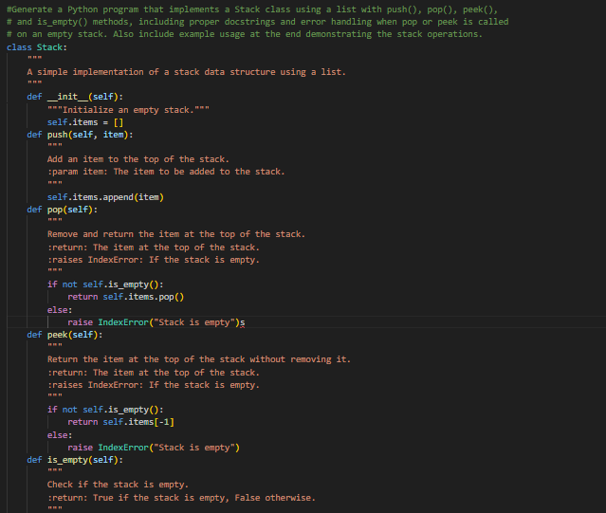
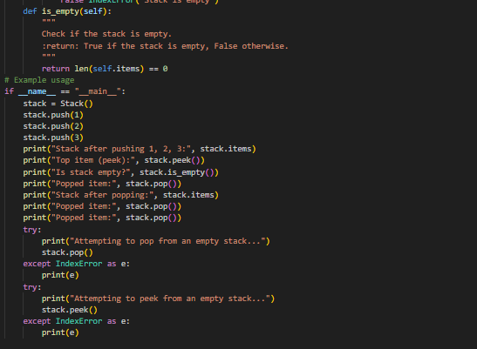
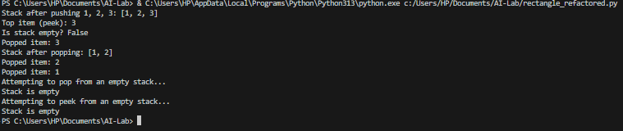
Task – 2
Queue Implementation
Task: Use AI to implement a Queue using Python lists.
Sample Input Code:
class Queue:
pass
Expected Output:
• FIFO-based queue class with enqueue, dequeue, peek, and size
methods.
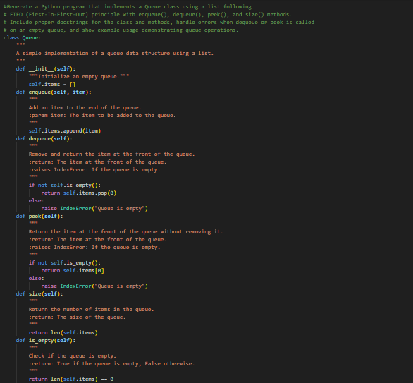
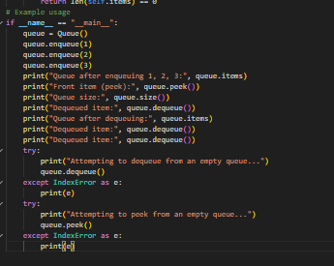
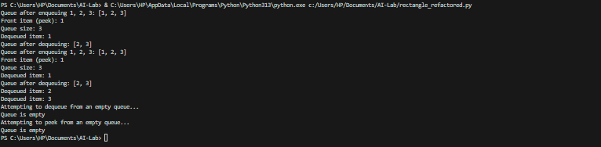
Task -3
Linked List
Task: Use AI to generate a Singly Linked List with insert and display
methods.
Sample Input Code:
class Node:
pass
class LinkedList:
pass
Expected Output:
• A working linked list implementation with clear method
documentation.
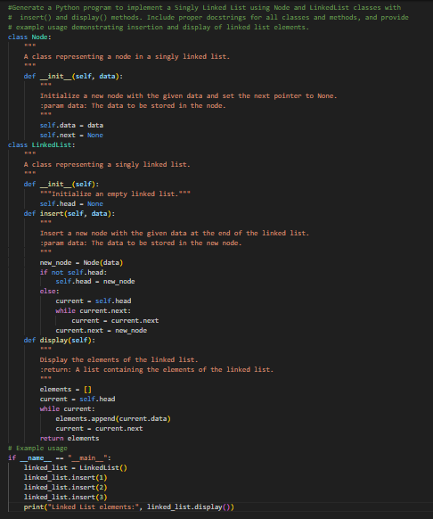
Task – 4
Binary Search Tree (BST)
Task: Use AI to create a BST with insert and in-order traversal methods.
Sample Input Code:
class BST:
pass
Expected Output:
• BST implementation with recursive insert and traversal methods.
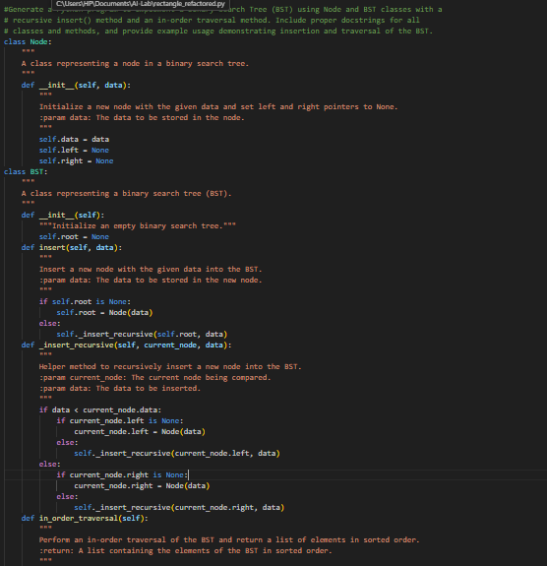
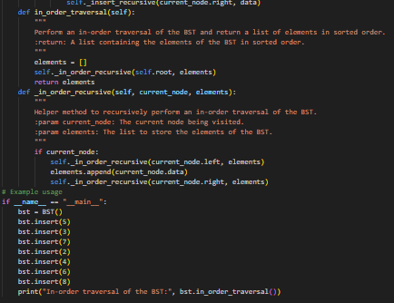
Task – 5
Hash Table
Task: Use AI to implement a hash table with basic insert, search, and
delete methods.
Sample Input Code:
class HashTable:
pass
Expected Output:
• Collision handling using chaining, with well-commented methods.
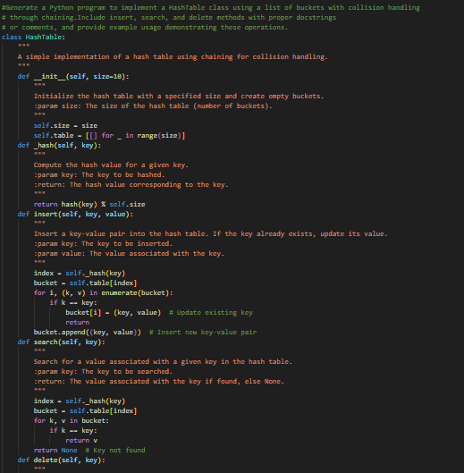
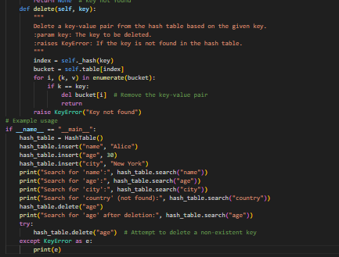
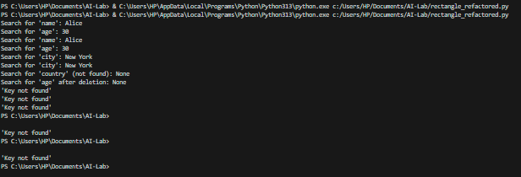
Task – 6
Graph Representation
Task: Use AI to implement a graph using an adjacency list.
Sample Input Code:
class Graph:
pass
Expected Output:
• Graph with methods to add vertices, add edges, and display
connections.
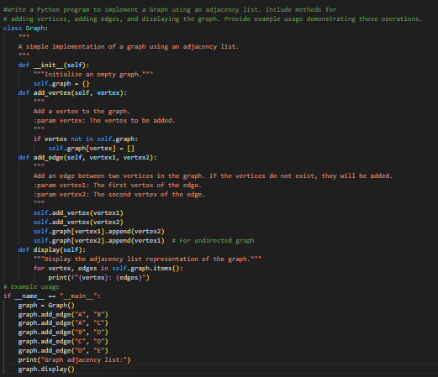
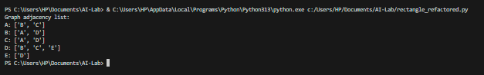
Task – 7
Priority Queue
Task: Use AI to implement a priority queue using Python’s heapq
module.
Sample Input Code:
class PriorityQueue:
pass
Expected Output:
• Implementation with enqueue (priority), dequeue (highest priority),
and display methods.
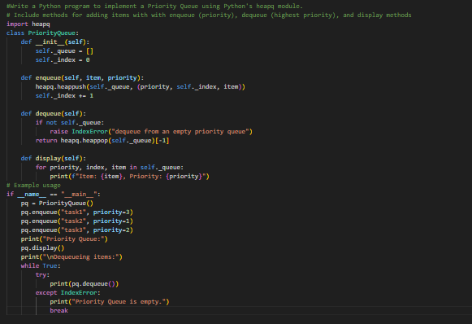
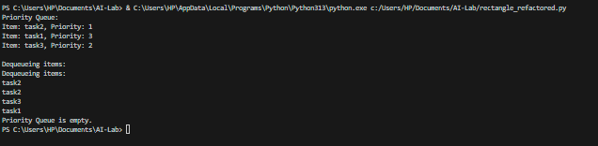
Task – 8
Deque
Task: Use AI to implement a double-ended queue using
collections.deque.
Sample Input Code:
class DequeDS:
pass
Expected Output:
• Insert and remove from both ends with docstrings.
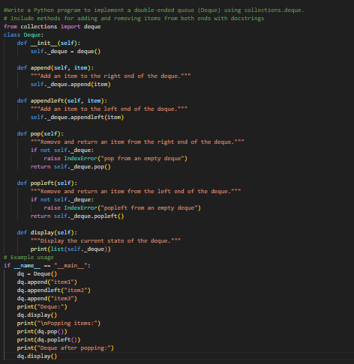
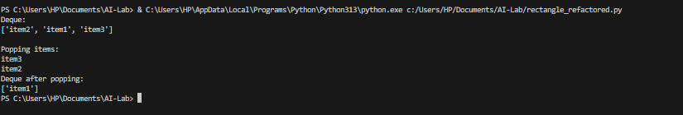
Task – 9
Real-Time Application Challenge – Choose the
Right Data Structure
Scenario:
Your college wants to develop a Campus Resource Management System
that handles:
1. Student Attendance Tracking – Daily log of students
entering/exiting the campus.
2. Event Registration System – Manage participants in events with
quick search and removal.
3. Library Book Borrowing – Keep track of available books and their
due dates.
4. Bus Scheduling System – Maintain bus routes and stop
connections.
5. Cafeteria Order Queue – Serve students in the order they arrive.
Student Task:
• For each feature, select the most appropriate data structure from
the list below:
o Stack
o Queue
o Priority Queue
o Linked List
o Binary Search Tree (BST)
o Graph
o Hash Table
o Deque
• Justify your choice in 2–3 sentences per feature.
• Implement one selected feature as a working Python program with
AI-assisted code generation.
Expected Output:
• A table mapping feature → chosen data structure → justification.
• A functional Python program implementing the chosen feature
with comments and docstrings.
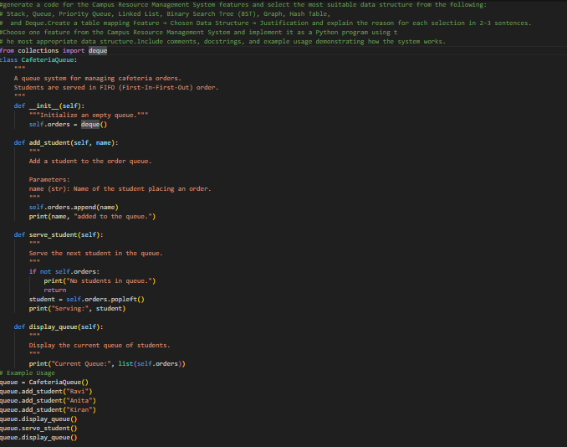
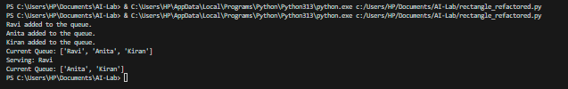
Task – 10
Smart Hospital Management System – Data
Structure Selection
A hospital wants to develop a Smart Hospital Management System that
handles:
1. Patient Check-In System – Patients are registered and treated in
order of arrival.
2. Emergency Case Handling – Critical patients must be treated first.
3. Medical Records Storage – Fast retrieval of patient details using
ID.
4. Doctor Appointment Scheduling – Appointments sorted by time.
5. Hospital Room Navigation – Represent connections between
wards and rooms.
Student Task
• For each feature, select the most appropriate data structure from
the list below:
o Stack
o Queue
o Priority Queue
o Linked List
o Binary Search Tree (BST)
o Graph
o Hash Table
o Deque
• Justify your choice in 2–3 sentences per feature.
• Implement one selected feature as a working Python program with
AI-assisted code generation.
Expected Output:
• A table mapping feature → chosen data structure → justification.
• A functional Python program implementing the chosen feature
with comments and docstrings.
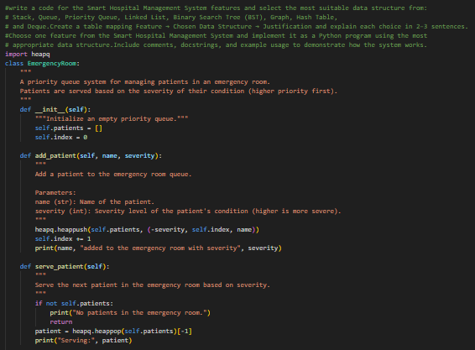
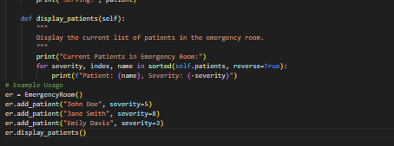
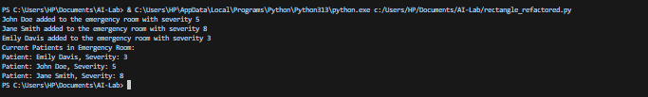
Task – 11
Smart City Traffic Control System
A city plans a Smart Traffic Management System that includes:
1. Traffic Signal Queue – Vehicles waiting at signals.
2. Emergency Vehicle Priority Handling – Ambulances and fire trucks
prioritized.
3. Vehicle Registration Lookup – Instant access to vehicle details.
4. Road Network Mapping – Roads and intersections connected
logically.
5. Parking Slot Availability – Track available and occupied slots.
Student Task
• For each feature, select the most appropriate data structure from
the list below:
o Stack
o Queue
o Priority Queue
o Linked List
o Binary Search Tree (BST)
o Graph
o Hash Table
o Deque
• Justify your choice in 2–3 sentences per feature.
• Implement one selected feature as a working Python program with
AI-assisted code generation.
Expected Output:
• A table mapping feature → chosen data structure → justification.
• A functional Python program implementing the chosen feature
with comments and docstrings.
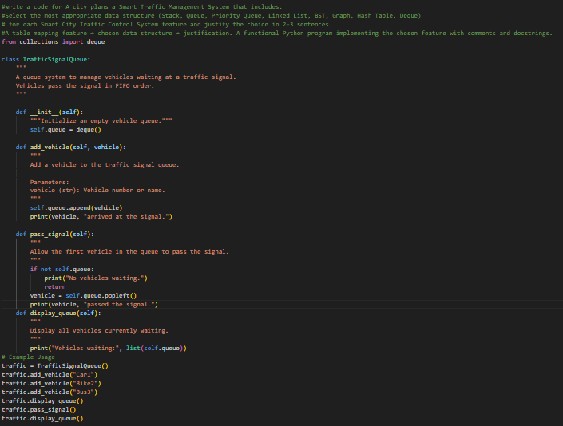
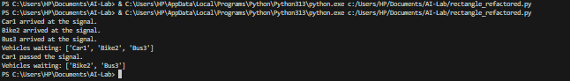
Task – 12
Smart E-Commerce Platform – Data Structure
Challenge
An e-commerce company wants to build a Smart Online Shopping System
with:
1. Shopping Cart Management – Add and remove products
dynamically.
2. Order Processing System – Orders processed in the order they are
placed.
3. Top-Selling Products Tracker – Products ranked by sales count.
4. Product Search Engine – Fast lookup of products using product ID.
5. Delivery Route Planning – Connect warehouses and delivery
locations.
Student Task
• For each feature, select the most appropriate data structure from
the list below:
o Stack
o Queue
o Priority Queue
o Linked List
o Binary Search Tree (BST)
o Graph
o Hash Table
o Deque
• Justify your choice in 2–3 sentences per feature.
• Implement one selected feature as a working Python program with
AI-assisted code generation.
Expected Output:
• A table mapping feature → chosen data structure → justification.
• A functional Python program implementing the chosen feature
with comments and docstrings.
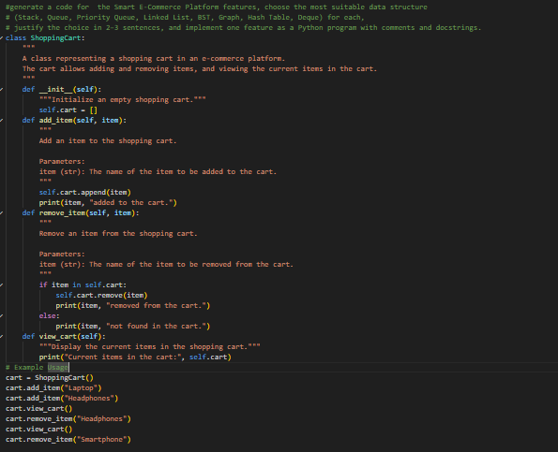
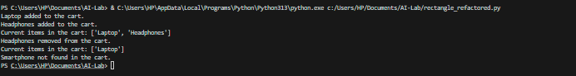
Task – 13
Smart Logistics & Warehouse Management
Scenario:
A logistics company wants to implement:
1. Shipment Processing
2. Urgent Shipment Priority
3. Product Lookup by Code
4. Warehouse Network Connectivity
5. Inventory Add/Remove Operations
Student Task
• For each feature, select the most appropriate data structure from
the list below:
o Stack
o Queue
o Priority Queue
o Linked List
o Binary Search Tree (BST)
o Graph
o Hash Table
o Deque
• Justify your choice in 2–3 sentences per feature.
• Implement one selected feature as a working Python program with
AI-assisted code generation.
Expected Output:
• A table mapping feature → chosen data structure → justification.
• A functional Python program implementing the chosen feature
with comments and docstrings.
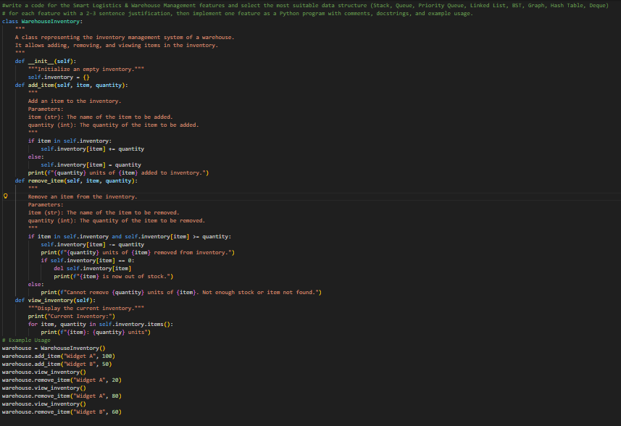
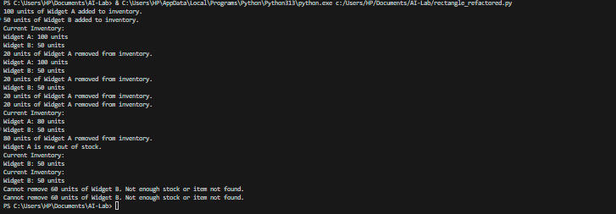
Task -14
Smart Banking Management System – Data
Structure Challenge
A bank plans to develop a Smart Banking System that includes:
1. Customer Service Token System – Customers are served in order
of arrival.
2. Loan Approval Priority Handling – High-value or urgent loans
processed first.
3. Account Information Lookup – Fast retrieval of customer details
using Account Number.
4. Transaction History Management – Maintain chronological
transaction records.
5. ATM Network Connectivity – Represent connections between
ATMs across cities.
Student Task:
• For each feature, select the most appropriate data structure from
the list below:
o Stack
o Queue
o Priority Queue
o Linked List
o Binary Search Tree (BST)
o Graph
o Hash Table
o Deque
• Justify your choice in 2–3 sentences per feature.
• Implement one selected feature as a working Python program
with AI-assisted code generation.
Expected Output:
• A table mapping feature → chosen data structure → justification.
• A functional Python program implementing the chosen feature
with comments and docstrings.
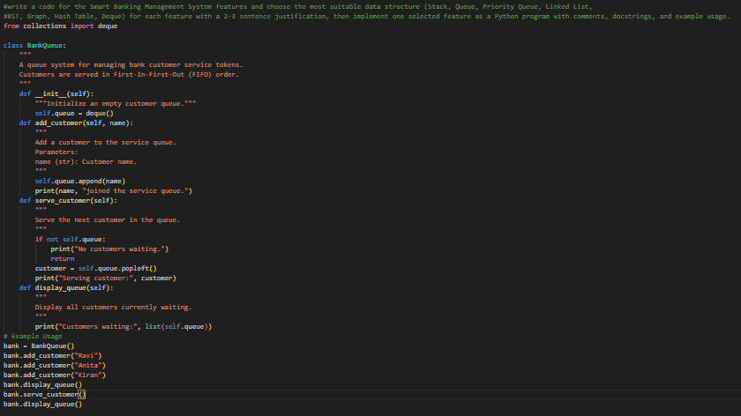
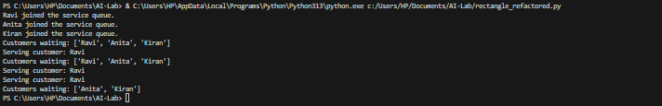
Task – 15
Online Learning Management System – Data
Structure Selection
An online education platform wants to develop a Learning Management
System that handles:
1. Student Login Authentication – Quick validation of user
credentials.
2. Assignment Submission Queue – Submissions processed in order
of upload.
3. Top Performer Ranking – Rank students based on scores.
4. Course Prerequisite Structure – Represent subject dependencies.
5. Undo Feature in Online Editor – Reverse recent actions.
Student Task:
• Select the most appropriate data structure for each feature from
the given list.
• Justify your selection in 2–3 sentences per feature.
• Implement one selected feature in Python using AI-assisted code
generation.
Expected Output:
• Feature → Data Structure → Justification table.
• Functional Python program with proper documentation.
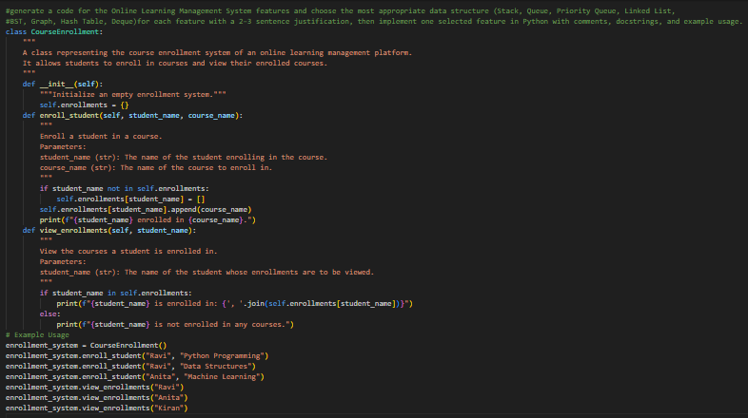
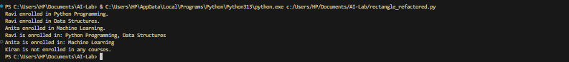
Task – 16
Smart Airport Management System – Data
Structure Challenge
An airport authority plans to implement:
1. Passenger Check-In Queue – Process passengers in order of
arrival.
2. Emergency Landing Priority – Aircraft in emergency get priority.
3. Flight Information Lookup – Fast search using Flight ID.
4. Air Route Connectivity – Airports connected via routes.
5. Boarding Process (Last-In First-Out Cabin Storage) – Overhead
luggage management simulation.
Student Task:
• Choose suitable data structures from the provided list.
• Provide 2–3 sentence justification per feature.
• Implement one feature in Python with comments and docstrings
using AI assistance.
Expected Output:
• Mapping table.
• Working Python implementation.
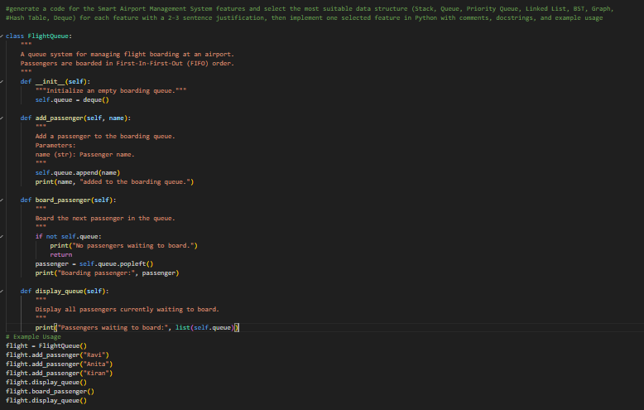
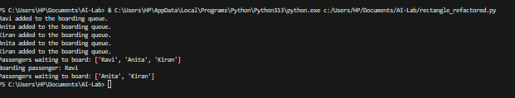
Task – 17
Smart Social Media Platform – Data Structure
Selection
A social media company wants to develop a system that includes:
1. News Feed Generation – Display posts chronologically.
2. Trending Hashtags Tracker – Rank hashtags by usage frequency.
3. User Profile Search – Quick lookup using username.
4. Friend Network Representation – Represent user connections.
5. Message Undo Feature – Allow last sent message to be
withdrawn.
Student Task:
• Select appropriate data structures from the list.
• Justify your choices clearly.
• Implement one selected feature as a Python program using AI-
assisted code generation.
Expected Output:
• Table mapping features to data structures with justification.
• Working Python code with docstrings and comments.
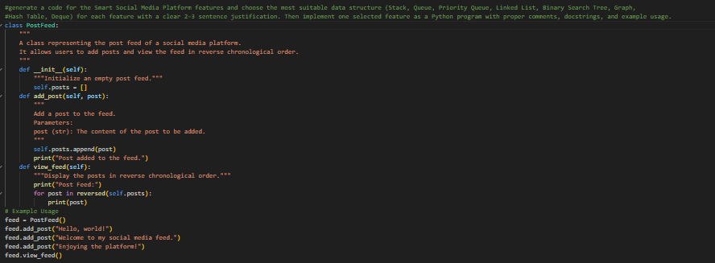
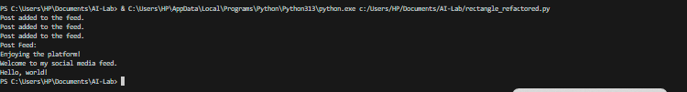
Task – 18
Smart University Hostel Management
Scenario:
A university wants to build a hostel management system that manages:
1.Room Allotment
2. Medical Emergency Handling
3. Student Record Retrieval
4. Hostel Block Connectivity
5. Visitor Entry Log
Student Task
• For each feature, select the most appropriate data structure from
the list below:
o Stack
o Queue
o Priority Queue
o Linked List
o Binary Search Tree (BST)
o Graph
o Hash Table
o Deque
• Justify your choice in 2–3 sentences per feature.
• Implement one selected feature as a working Python program with
AI-assisted code generation.
Expected Output:
• A table mapping feature → chosen data structure → justification.
• A functional Python program implementing the chosen feature
with comments and docstrings.
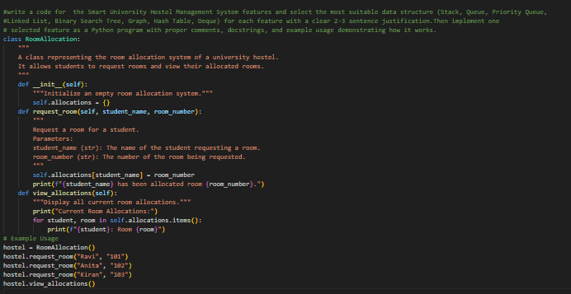
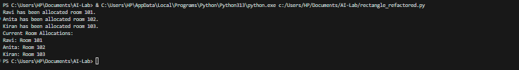
Task – 19
Smart Electricity Distribution System
Scenario:
An electricity board plans to develop a system that includes:
1. Complaint Handling
2. Fault Priority Handling
3. Consumer Record Lookup
4. Power Grid Connectivity
5. Meter Reading History Tracking
Student Task
• For each feature, select the most appropriate data structure from
the list below:
o Stack
o Queue
o Priority Queue
o Linked List
o Binary Search Tree (BST)
o Graph
o Hash Table
o Deque
• Justify your choice in 2–3 sentences per feature.
• Implement one selected feature as a working Python program with
AI-assisted code generation.
Expected Output:
• A table mapping feature → chosen data structure → justification.
• A functional Python program implementing the chosen feature
with comments and docstrings.
